How to Support Learning at Home

Our Sensory Story this half term is ‘All About Colour’ by Jordan Garratt. Jordan trained as a specialist education teacher in 2009. Throughout her career, she has worked exclusively with over 400 children with SEN with a range of needs, ages and abilities.
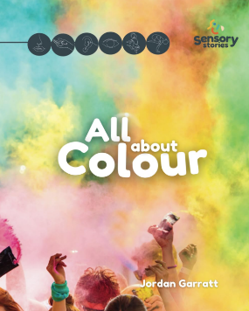
A sensory story about colours around us. A sensory story is an accessible learning tool told through short stories involving sensory experiences. These stories build interest, whilst also enabling all to access information in a way that suits them.

Little Wandle Phonics:

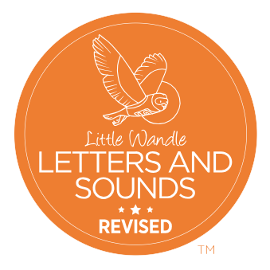
The following links will help you support your child with saying their sounds. There are also some useful videos so you can see how they are taught at school and feel confident about supporting their reading at home.
For parents | Letters and Sounds (Nursery Rhymes - Videos)
For parents | Letters and Sounds (Nursery Rhymes - Downloads)

