How to Support Learning at Home

Our Sensory Story this half term is ‘Brown Bear, Brown Bear, What Do You See?’ by internationally bestselling and award-winning author, Eric Carle.
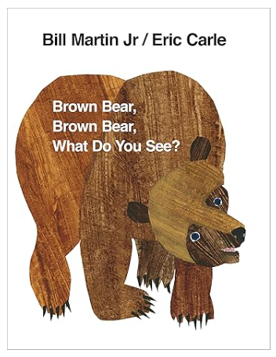

Exuberantly coloured artwork and favourite animals make this rhythmic story the perfect introduction to looking and learning about colours. Each spread leads seamlessly into the next and young children will delight in Eric's colourful collage animals and simple repetitive language.

Little Wandle Phonics:
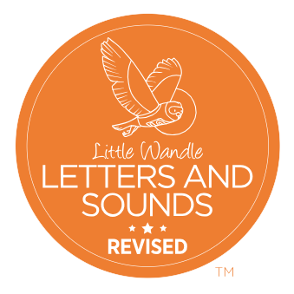
The following links will help you support your child with saying their sounds. There are also some useful videos so you can see how they are taught at school and feel confident about supporting their reading at home.
For parents | Letters and Sounds (Nursery Rhymes - Videos)
For parents | Letters and Sounds (Nursery Rhymes - Downloads)

