Welcome Booklet

Stanton Early Years

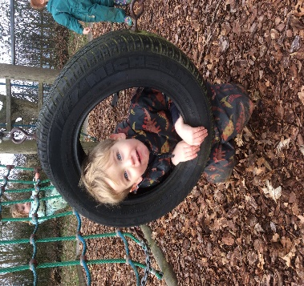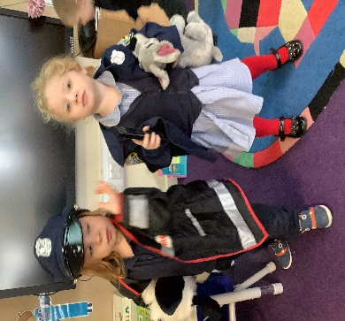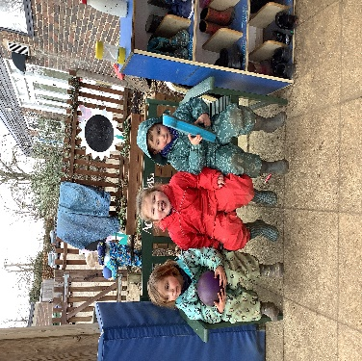

Acorn Class (Nursery)

Hazel Class (Reception)

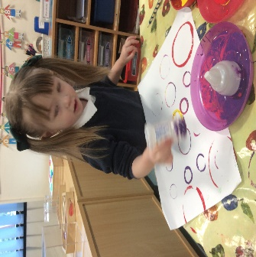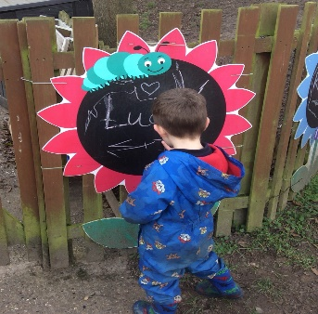



The progress a child makes between the ages of three and five is remarkable. All children learn more in the period from birth to five years old than any other time in their lives. We are delighted that you have chosen us to play such an important part in your child’s growth during this period.

We offer a caring and stimulating setting to encourage that development and would like to extend a warm welcome to you and your child.

We hope you find this welcome booklet a useful guide for your child’s first experience of school.



Stanton Community Primary School

Upthorpe Road, Stanton, Bury St Edmunds, IP31 2AW

Telephone: 01359 250225

Email: admin@stanton.suffolk.sch.uk

Website: www.stantonprimarysch.co.uk

Head teacher: Mrs E Bonnelykke B.Sc. (Hons), PGCE, NPQH

Hazel Class Times

School gates open: 8.40am

School Starts at 8.45am

School Finishes: 3.20pm

Wrap around care is available from 7.50am—4.30pm.

Nursery Opening Times

Morning: 8.40am—11.40 am

Lunch Club: 11.40am—12.30pm

Afternoon: 12.30pm—3.30pm

Wrap around care is available from 7.50am—4.30pm.

Our Aims

We strive to:

* Provide a happy, safe and secure environment full of love, care and respect for each other.
* Create a stimulating and fun environment with child-centred and adult initiated play, which promotes children’s learning and fosters enquiring minds and happy learners.
* Deliver a broad and balanced Early Years Curriculum based on the seven Areas of Learning outlined in the Foundation Stage Framework.
* Work in partnership with parents and value the help and guidance they give to their children.
* Help children to make sense of the world they live in and help them to take a positive role in it.
* Encourage children to make their own decisions and choices.
* Provide an environment rich in language to encourage communication skills.
* Form positive relationships built on mutual trust and respect.
* Ensure that children in our Nursery are ready for school by developing their confidence and independence.
* Make the transition between Nursery and Reception seamless by working as an Early Years Base, sharing knowledge, resources, information and expertise.
* Ensure that the transition between Reception and Year 1 is well planned and prepared for with regular opportunities for visits and information sharing.

Our Early Years Staff Team.



**Mrs. Amanda Smith**

**Deputy Head, EYFS Lead & Nursery Teacher**

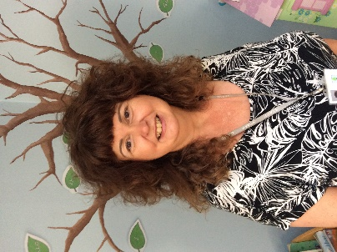

**Mrs. Marie Leighton Mrs. Jo Edney**

**Nursery Teacher Hazel Class Teacher**

**Early Years Teaching Assistants**

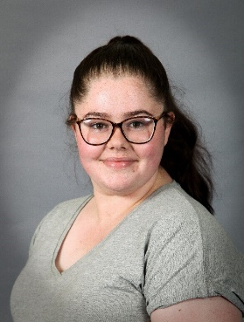

**Mrs Neale,**

**Mrs Wright, Mrs Burnett, Miss Macey**

**Partnerships with Parents**

We want to work closely with you. Good communication between staff and parents enables us to inform each other of relevant matters concerning your child. We appreciate being informed of any change at home that might affect your child and will treat anything you tell us in strict confidence.

**Updates and News**

We regularly inform you about the activities and learning experiences that your child will be taking part in. We update parents using the following:

* Weekly school newsletter (also accessible via our school website)
* Knowledge Organisers (Half Termly)
* Class pages on the school website
* ****Class Dojo

**Class Dojo**

This is an online app that we use to upload pictures and information of your children’s learning to their individual portfolio. We post information about class events and reminders about equipment. You will have access to the whole school story too, which will enable you to see whole school messages and stories.

You can also use this platform to message the teacher directly.

**Stay and Play Workshops**

Stay and play workshops are planned throughout the year—these will include coming in to play and learn alongside your child, story café, special celebrations with us or join us for library time. Details of these sessions will be available on the school newsletter and dojo.

**How You Can Help Us**

**Bringing and Collecting Your Child**

Please try to arrive on time as this allows your child to feel confident on their arrival and departure from school. Please tell us if someone different will be collecting your child or if you are going to be late for any reason via Class Dojo or phoning the school office.

**Absences and Illness**

Please inform us of any change of address or contact numbers so that we can get in touch with you if your child becomes unwell.

If your child is absent, please contact the school as soon as possible

(See page 2)

If your child has had sickness or diarrhoea, please keep them at home for 48 hours after their last period of sickness.

**Toileting**

Ideally, all children will be toilet trained before they are admitted to Nursery, however we do understand that some children are not fully toilet trained and know that accidents will happen. Please supply extra nappies and wipes in their bag as well as a change of clothing. If your child has an 'accident' in school, we will change them into their own spare clothes but have a limited supply of clothes for emergencies. We just ask that you please return any borrowed clothes as soon as possible as supplies are limited.

**Clothing and Personal Items**

* All children should be provided with a small clearly labelled bag containing a full change of clothes in case of accidents or messy play.
* All children should be sensibly and comfortably dressed in clothes that they can cope with when going to the toilet, playing in the water or changing for outdoor play. Shoes with Velcro (clearly named and labelled) are ideal. All children will need to change their shoes for wellies to enable them to play in the garden during the winter and spring months. It is important that they are able to develop independence with this.
* We encourage children in Nursery to wear school uniform, as it is both practical and a way of supporting transition into Primary School.
* Children in Hazel class are provided with a school book bag and PE bag free of charge.

**Uniform List:**

 PE Kit (Hazel Class Only):

Shorts (navy or black)

T-shirt (white)

Trainers

Track suit bottoms (black or navy)

Sweatshirt or Hooded top (black or navy)

Grey trousers, shorts, skirts or pinafore dresses.

School Sweatshirt

Navy polo shirt

Blue chequered dress (summer)

**Sunhat**

**Welly Boots**

**Puddle suit**

 Ensure that your child's coat, hat, shoes and welly boots, for example, are named and that they do bring a coat on cooler days as we value our outdoor learning. Every child will have his or her own coat peg with name and picture for them to hang up their belongings.

**Children should not bring any toys to school, as they can easily get lost or broken.**

**We hope that you appreciate that there can be times when the children’s trousers, socks or tights may get dirty!**

**Nursery/EYFS Fund**

In line with other nurseries, we ask for a voluntary contribution of **£1.00** per week towards extra supplies such as ingredients for baking and sensory play including making play dough etc. It is also used to enhance the snack for the Nursery including items like crackers, breadsticks and cereal. You can make this donation on school gateway.

In Hazel class we ask for a half termly, voluntary, contribution of £5 to enable us to enhance our environment through sensory play (including shaving foam, lentils, rice and pasta), home-made playdough and cooking ingredients.

**Lunch at School**

**All children are provided with a school water bottle to enable them to have a drink of water throughout the day.**

All children who require a school lunch will need to have this pre-booked on ‘School Gateway’. Children in Hazel Class and up to Year 2 receive universal free school lunches so no payment is required.

Children in Nursery, who are not in receipt of 30 hours funding but would like to access our Lunch Supervision, will need to book and pay on ‘School Gateway’, even if they are having a packed lunch, before each lunchtime session attended. A school meal can also be booked on line (for an additional cost). Please see our class page on the school website to access our charging policy.

**Packed Lunches**

On arrival, children are asked to put their lunchbox into a class box to enable us to check what children are having for lunch and that all children have a lunch. Your child’s packed lunch should not contain fizzy drinks, sweets, nuts or chocolate bars please.

**Rainbow Club**

Wrap around care is available from 7.50am in the morning for breakfast club and after school provision from 3.20pm until 4.30pm. This needs to be booked and paid for in advance on ‘School Gateway’.

**Curriculum**

We plan in a cross-curricular way; using the seven Areas of Learning identified in the **Foundation Phase Framework**, ensuring that children’s skills are developed in a meaningful context. Each Term has a different overarching focus, which leads to a half termly topic; however, these are flexible based on children’s interests, knowledge and engagement.

**The seven Areas of Learning are:**

**1. Personal, social and emotional development,**

**2. Communication and language. 3. Physical development.**

**4. Literacy. 5. Mathematics.**

**6. Understanding the world. 7. Expressive arts and design.**

All of those areas of learning are connected together. The characteristics of effective teaching and learning weave through them all. That is because children in the early years are becoming more powerful learners and thinkers. These characteristics develop as they learn to do new things, acquire new skills, develop socially and emotionally, and become better communicators.

**The characteristics of effective teaching and learning**

**Playing and exploring** - children investigate and experience things, and ‘have a go’

**Active learning** - children concentrate and keep on trying if they encounter difficulties, and enjoy achievements.

**Creating and thinking critically** - children have and develop their own ideas, make links between ideas, and develop strategies for doing things.

**When we succeed in giving every child the best start in their early years, we give them what they need today. We also set them up with every chance of success for tomorrow.**

**Our Environment**

Children in our Early Years have open access to our large outdoor area and we consider this as an ‘outside classroom’. We greatly value the opportunities for learning on a larger or more physical scale that the outdoor environment offers to children.

Our classrooms are well resourced and offer a variety of areas for learning. They are set out each day with a range of activities including construction, mark making, messy play, imaginative play, investigative activities, puzzles, books and creative opportunities. We are also able to make use of the wider school environment and resources including the hall, library, cookery room, playing field, and forest to further enhance our learning opportunities.

**Learning in Early Years**

In Nursery children develop a love of maths through games, songs, rhymes and play using concrete manipulatives. There is a focus on the following counting principles; one to one correspondence, stable order and cardinal principle. Children’s fine motor skills are a focus to develop 1-1 correspondence so children count each object only once.

In Reception maths is taught using a ‘Maths Mastery’ approach. High quality learning environments and meaningful interactions with adults support children to develop mathematical thinking and discussion. Children learn through games and tasks using concrete manipulatives and pictorial structures and representations, which are then rehearsed, applied and recorded within their own child-led exploration.

**Phonics**

We have a daily phonics session where, in Nursery, we focus on general sound discrimination – environmental sounds, instrumental sounds, body percussion, rhythm and rhyme, alliteration, voice sounds, oral blending and segmenting.

The daily phonics sessions in Hazel class are systematically taught using our ‘Little Wandle Letters and Sounds’ program and consists of learning to hear, read, say and write sounds, high frequency words and tricky words. As children progress this leads to blending and segmenting sounds for reading and writing. Once the children are blending they are introduced to a reading book and listened to 3x a week, each with a slightly different focus.

**School Library**

Children are encouraged to borrow a book from our School Library. These are changed once a week – please check school dojo for your child’s Library day.

**NURSERY**

**Cooking**

We cook on a weekly basis a variety of foods and snacks, encouraging the children to participate as fully as possible. We discuss where food comes from, the changing states of materials as we mix and cook and provide children opportunities to use different kitchen tools.

**Welly Walk**

Children take part in a weekly ‘Welly Walk’ session around our extensive school grounds, which often involves finishing up in our on-site forest school area. We are able to use the school climbing equipment, which allows the children to take risks and use their physical skills.

**Write Dance**

The children participate in regular ‘write dance’ sessions which is a program that incorporates a story, music and actions and then finally drawing different early patterns to the music. This supports children’s gross motor and fine motor skills.

**Transition to School**

**Children from our school Nursery**

We are extremely proud of the transition from our school Nursery to Reception into full time schooling. The children are almost unaware of any changes due to the seamless approach and open base environment that we provide. As well as using different areas of the school to conduct learning activities, such as the school library, the dining room to collect lunches, the school hall and drama studio, the children are able to build strong relationships with the Reception class teachers and school staff. This enables the children to confidently start school, full time, already aware of the routines, rules and environment in Hazel class.

The Early Years team across Nursery and Reception work closely together throughout your child’s journey in Early Years to really get to know your child as an individual and provide the very best experiences possible.

**Children from other settings**

The Reception class teacher will be in contact with the early years setting that your child attends to gather information about your child’s development, friendships, likes and dislikes and any additional support they may be receiving in the last half term of the academic year.

An invitation will be sent for children to attend several taster sessions, which will have been carefully planned to incorporate friendship groups where possible, gradually increasing in the amount of time spent in school.

All new parents will be invited to sign up to Class Dojo where you will be able to access videos and welcome messages from the early year’s team. Parents will also be invited to attend an early years information evening, which will provide an opportunity to ask questions from the team that will support your child.

**SEND Support**

At Stanton, we are proud to provide a safe, stimulating and inclusive learning environment where every member of our school community is valued and respected. We have high expectations of all our children. We promote high standards in learning, behaviour and attitude, encouraging every child to reach their full potential, academically and socially.

We have a highly qualified and experienced SEN Coordinator who oversees any additional assessment or support that may be needed as well as supervising targeted interventions.

We employ our own Emotional Support Worker who supports all pupils and where appropriate, their parents or carers and provides specific help for those children most at risk (or showing signs) of social, emotional and behavioural problems. We also work closely with CAMHS and other agencies such as Health Visitors, Family Support Practitioners and the School Nursing Team, County Inclusive Support Service.

**We hope that the information in this brochure has been helpful. Should you have any questions please do not hesitate to contact the school office.**