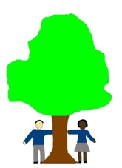Computing Curriculum Long Term Plan

|  |  |  |  |  |  |
| --- | --- | --- | --- | --- | --- |
| **Year 1** | **Year 2** | **Year 3** | **Year 4** | **Year 5** | **Year 6** |
| Online Safety | Online Safety | Online Safety | Online Safety | Online Safety | Online Safety |
| Programming  Bee-Bot | Creating Media | Video Trailers | Website Design | Micro: bit | Bletchley Park |
| Improving mouse skills | Programming –Scratch Junior | Comparison cards: Data base skills | Computational Thinking | Search Engines | Programming: Intro to Python |

Digital Literacy

Computer Science

Information Technology